Employee Turnover Data Quality Assessment & Workforce Data Preparation Pipeline

Executive Summary
This report presents the data profiling and data cleaning process performed on the Employee Turnover dataset. The objective is to prepare the dataset for analysis by identifying and resolving data quality issues such as missing values, duplicate entries, inconsistent formatting, and outliers.
The cleaned dataset supports the organization in analyzing employee turnover trends and enables the development of effective retention strategies based on reliable data.

Dataset Assessment & Profiling

Dataset Overview
The dataset contains:
- Total Records (Rows): 10,200 (approx.)
- Total Variables (Columns): 16

original_shape = df.shape

original_shape
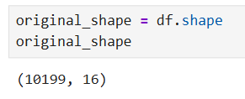
Stores and shows the dataset size before cleaning.

Data Structure & Variable Classification
The dataset consists of both numerical and categorical variables:
Variable | SQL Data Type | Analytical Type | Subtype
EmployeeNumber | INT | Categorical | Nominal
Age | INT | Numerical | Discrete
Tenure | INT | Numerical | Discrete
Turnover | VARCHAR | Categorical | Binary
HourlyRate | VARCHAR | Numerical | Continuous
HoursWeekly | INT | Numerical | Discrete
CompensationType | VARCHAR | Categorical | Nominal
AnnualSalary | FLOAT | Numerical | Continuous
DrivingCommuterDistance | INT | Numerical | Discrete
JobRoleArea | VARCHAR | Categorical | Nominal
Gender | VARCHAR | Categorical | Nominal
MaritalStatus | VARCHAR | Categorical | Nominal
NumCompaniesPreviouslyWorked | INT | Numerical | Discrete
AnnualProfessionalDevHrs | INT | Numerical | Discrete
PaycheckMethod | VARCHAR | Categorical | Nominal
TextMessageOptIn | VARCHAR | Categorical | Binary

These classifications were determined through inspection of the raw dataset values and verification using df.info().
Numerical variables represent measurable quantities, while categorical variables represent labels or grouped classifications. Subtypes such as nominal, binary, discrete, and continuous were assigned based on how each variable behaves during analysis.
The HourlyRate variable was initially classified as VARCHAR because the raw dataset contained currency symbols within the values.

df.info()
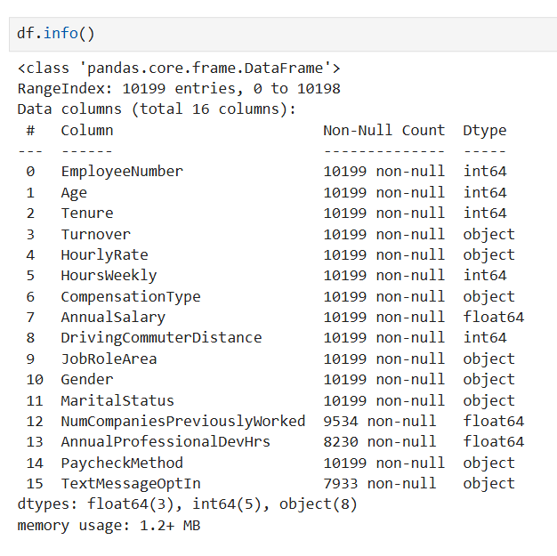

Figure 1: Dataset structure and data types verification using df.info()

The dataset structure and initial data types were verified using df.info(), which provided a complete overview of column data types, non-null counts, and memory usage. This output was used to validate and refine the classification of each variable into numerical and categorical types.

Dataset Preview & Field Validation
Sample observable values from the dataset include:
Variable | Sample Observable Values
EmployeeNumber | 1, 2, 3
Age | 28, 33, 22
Tenure | 6, 2, 1
Turnover | Yes, No
HourlyRate | 24.37, 22.52, 30.10
HoursWeekly | 40, 40, 38
CompensationType | Salary
AnnualSalary | 50689.6, 46841.6
DrivingCommuterDistance | 89, 35, 12
JobRoleArea | Research, Information Technology
Gender | Female, Male
MaritalStatus | Married, Single
NumCompaniesPreviouslyWorked | 3, 6, 1
AnnualProfessionalDevHrs | 7, 8, 5
PaycheckMethod | Mailed Check, Direct Deposit
TextMessageOptIn | Yes, No

df.head()
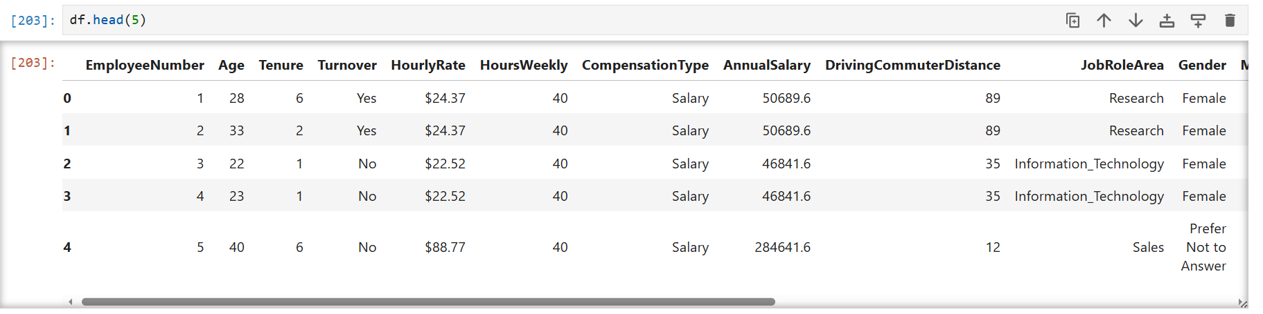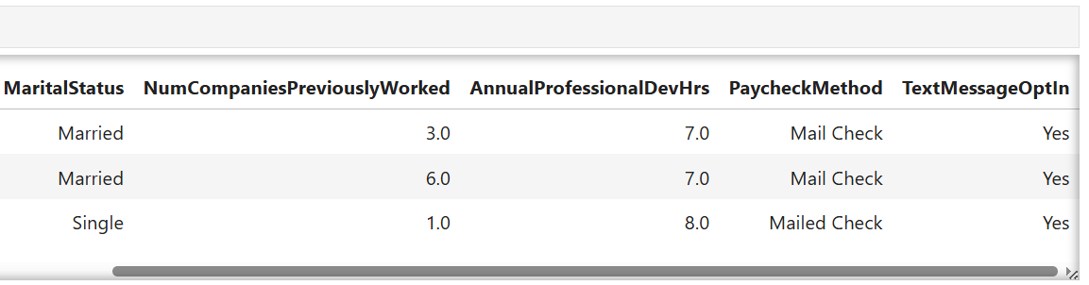

Figure 2: Sample dataset preview using df.head()

Explanation:
The sample observable values were extracted using df.head(), which provides a preview of actual dataset records. These values help validate the presence of expected categories and numerical ranges across all variables in the dataset.

Data Quality Assessment

Data Quality Assessment Findings
The dataset was inspected using Python-based exploratory data analysis (EDA) techniques to identify data quality issues prior to cleaning. Multiple validation checks were performed to assess completeness, consistency, validity, and accuracy of the dataset.

Missing Values

df.isnull().sum()

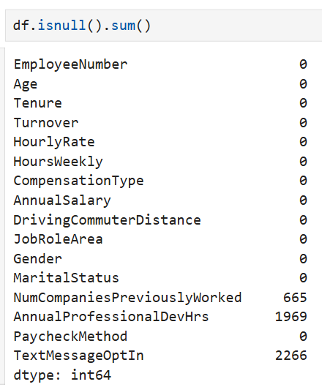
Explanation:
Missing value analysis was performed to identify incomplete records in the dataset. The inspection revealed missing values in AnnualProfessionalDevHrs and NumCompaniesPreviouslyWorked, indicating that imputation techniques would be required during data cleaning.

Duplicate Records

df.duplicated().sum()
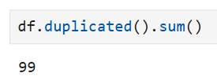
Explanation:
Duplicate detection was performed to ensure each row represents a unique employee record. The analysis identified duplicate entries, which could lead to biased statistical results and needed to be removed during cleaning.

Data Types & Structure

df.info()
Explanation:
The dataset structure was reviewed to verify correct data types, non-null counts, and memory usage. This step ensured that variables were correctly stored as numerical or categorical types and highlighted any inconsistencies in data formatting.

Unique Values & Inconsistencies

df.nunique()
df['PaycheckMethod'].value_counts()
df['JobRoleArea'].value_counts()
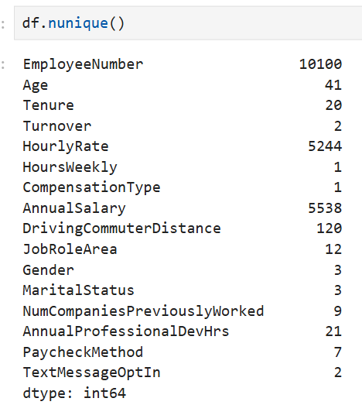
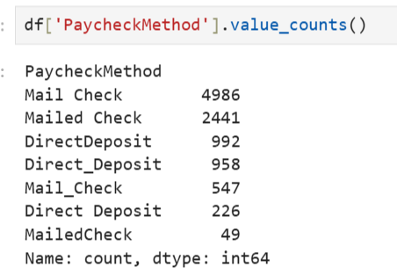
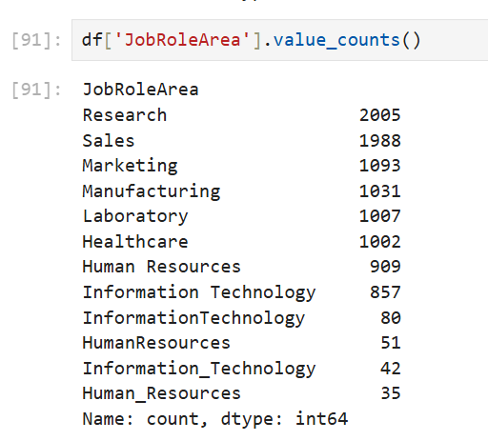
Explanation:
Categorical distributions were analyzed to detect inconsistent formatting and unexpected variations in text values. Issues were identified in PaycheckMethod and JobRoleArea, where multiple inconsistent text formats representing the same category values.

Outlier Detection

df.describe()
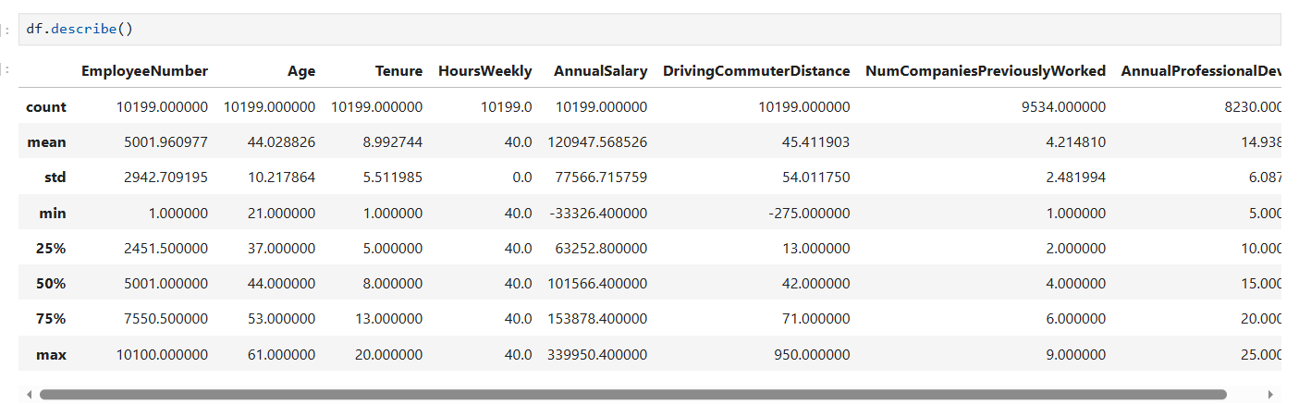
Explanation:
Descriptive statistics were used to identify extreme values in numerical variables. The analysis highlighted potential outliers in AnnualSalary, which could impact statistical analysis and modeling results.

Additional logical validation checks were performed:

(df['Age'] < 18).sum()
(df['AnnualSalary'] < 0).sum()
(df['HoursWeekly'] > 80).sum()
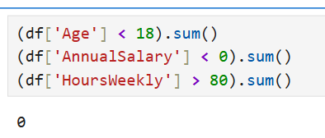
Explanation:
These checks were used to detect logically impossible values in the dataset, such as negative salary, unrealistic working hours, or underage employees. No or minimal violations were observed.

Identified Data Quality Challenges
The inspection revealed the following issues:

1. Missing Values

df.isnull().sum()
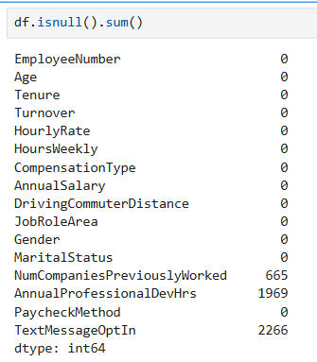
Figure: Missing values check using df.isnull().sum()

Explanation:
The dataset was checked for missing values across all columns using isnull().sum(). The output confirmed missing data in AnnualProfessionalDevHrs, NumCompaniesPreviouslyWorked, and TextMessageOptIn, indicating incomplete records that required imputation during data cleaning.

2. Duplicate Records

df.duplicated().sum()

Figure: Duplicate records detection using df.duplicated().sum()

Explanation:
Duplicate records were identified using df.duplicated().sum(). The result showed the presence of duplicate entries, meaning some employee records were repeated. These duplicates could lead to biased analysis if not removed.

3. Data Structure & Type Issues

df.info()
Figure: Dataset structure and data types using df.info()

Explanation:
The dataset structure was analyzed using df.info() to verify column data types and completeness. This step helped identify correct data types and highlighted any inconsistencies in variable formatting.

4. Inconsistent Categorical Values

df.nunique()
df['PaycheckMethod'].value_counts()
df['JobRoleArea'].value_counts()
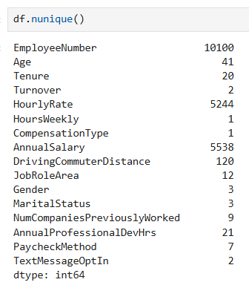
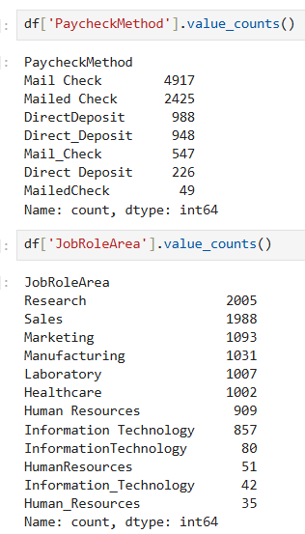
Figure: Categorical value distribution analysis

Explanation:
Categorical variables were analyzed using value_counts() and nunique() to detect inconsistent formatting. The analysis revealed variations in PaycheckMethod and JobRoleArea, where multiple representations of the same category existed.

5. Formatting Issues (Currency Symbols)

df['HourlyRate'].head()
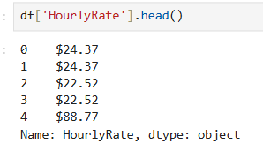
Figure: HourlyRate format inspection showing currency symbols

Explanation:
The HourlyRate column was inspected and found to contain currency symbols (e.g., $), which prevented direct numerical analysis. This issue required data cleaning by removing special characters and converting the column into numeric format.

6. Outliers Detection

df.describe()
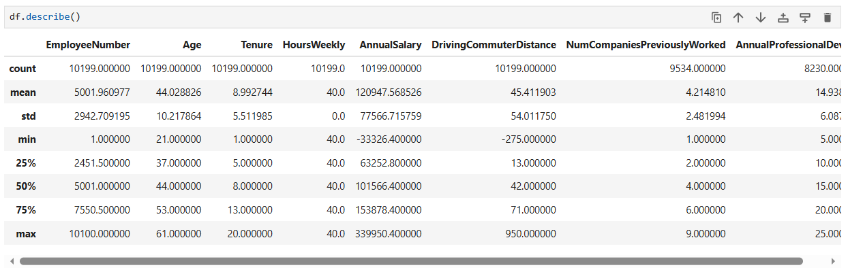
Figure: Statistical summary using df.describe()

Explanation:
Descriptive statistics were used to detect outliers in numerical variables. The analysis highlighted extreme values in AnnualSalary, which could distort statistical measures such as mean and standard deviation.

Data Preparation & Transformation Pipeline

Data Remediation Approach
The dataset was modified using Python to address the identified issues:
- Missing values were handled using statistical imputation
- Duplicate records were removed
- Inconsistent values were standardized
- Outliers were filtered using the IQR method
- Data types were corrected and standardized

Data Transformation & Quality Enhancement Process

1. Handling Missing Values

df.replace("N/A", np.nan, inplace=True)
df["AnnualProfessionalDevHrs"].fillna(df["AnnualProfessionalDevHrs"].median(), inplace=True)
df["NumCompaniesPreviouslyWorked"].fillna(df["NumCompaniesPreviouslyWorked"].median(), inplace=True)
df["PaycheckMethod"].fillna(df["PaycheckMethod"].mode()[0], inplace=True)
df["TextMessageOptIn"].fillna("No", inplace=True)
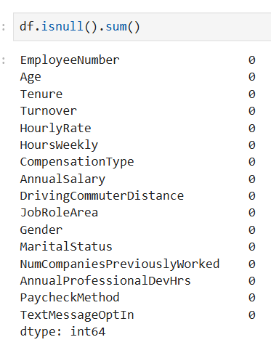
Explanation:
Missing values in numerical columns were replaced using the median to reduce the influence of outliers, while categorical variables were filled using the mode to maintain consistency.

2. Removing Duplicates

df.drop_duplicates(inplace=True)
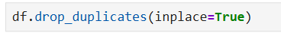
Explanation:
Duplicate records were removed to ensure that each observation represents a unique employee, improving data accuracy.

3. Fixing Inconsistent Values

df['PaycheckMethod'] = df['PaycheckMethod'].replace({
'Mail_Check': 'Mailed Check',
'MailedCheck': 'Mailed Check',
'Mail Check': 'Mailed Check',
'Direct_Deposit': 'Direct Deposit',
'DirectDeposit': 'Direct Deposit'
})
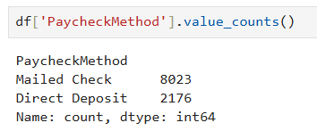
Explanation:
Inconsistent text formats were standardized to ensure uniform categorical values, which is critical for accurate grouping and analysis.

4. Outlier Treatment (IQR Method)

Q1 = df["AnnualSalary"].quantile(0.25)
Q3 = df["AnnualSalary"].quantile(0.75)
IQR = Q3 - Q1
lower_bound = Q1 - 1.5 * IQR
upper_bound = Q3 + 1.5 * IQR
df = df[(df["AnnualSalary"] >= lower_bound) & (df["AnnualSalary"] <= upper_bound)]
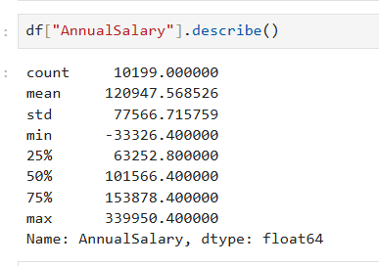
Explanation:
The IQR method was applied to remove extreme salary values that could distort statistical analysis and model performance.

5. Feature Standardization

df["Turnover"] = df["Turnover"].map({"Yes": 1, "No": 0})
df["TextMessageOptIn"] = df["TextMessageOptIn"].map({"Yes": 1, "No": 0})
Explanation:
Categorical variables were encoded into numeric format to support analytical modeling and improve computational efficiency.

df["Turnover"].value_counts()
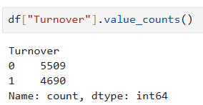

Shows how many times each turnover category (Yes/No) appears in the dataset.

df["TextMessageOptIn"].value_counts()
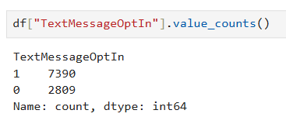
Shows how many times each opt-in category (Yes/No) appears in the dataset.

6. Data Type Fixing

df["HourlyRate"] = df["HourlyRate"].replace(r"[\$,]", "", regex=True).astype(float)
Explanation:
Data types were corrected to ensure numerical operations could be performed accurately.

df["AnnualSalary"] = pd.to_numeric(df["AnnualSalary"], errors="coerce")
Explanation:
Formatting issues such as currency symbols were removed to convert columns into usable numeric formats.

Business Value Delivered
• Improves overall data quality and consistency
• Enables accurate statistical analysis and machine learning modeling
• Reduces noise caused by duplicates, missing values, and outliers

Implementation Considerations
• Median imputation may reduce natural variability in the dataset
• Removing outliers may eliminate extreme but valid observations
• Data cleaning decisions may introduce slight bias depending on chosen techniques

Implementation Framework

# Load dataset

df = pd.read_csv("Employee Turnover Dataset.csv")

# Inspect dataset structure and missing values

df.info()

df.isnull().sum()

# Remove duplicate records

df.drop_duplicates(inplace=True)

# Replace invalid values with NaN

df.replace("N/A", np.nan, inplace=True)

# Fill missing numerical values using median

df["AnnualProfessionalDevHrs"].fillna(df["AnnualProfessionalDevHrs"].median(), inplace=True)

# Fill missing categorical values using mode

df["PaycheckMethod"].fillna(df["PaycheckMethod"].mode()[0], inplace=True)

# Fix inconsistent categorical values

df['PaycheckMethod'] = df['PaycheckMethod'].replace({...})

# Convert columns to correct data types

df["AnnualSalary"] = pd.to_numeric(df["AnnualSalary"], errors="coerce")

# Remove outliers using IQR method

# (calculation steps applied)

# Encode categorical variables

df["Turnover"] = df["Turnover"].map({"Yes": 1, "No": 0})

# Final validation

df.isnull().sum()

df.duplicated().sum()

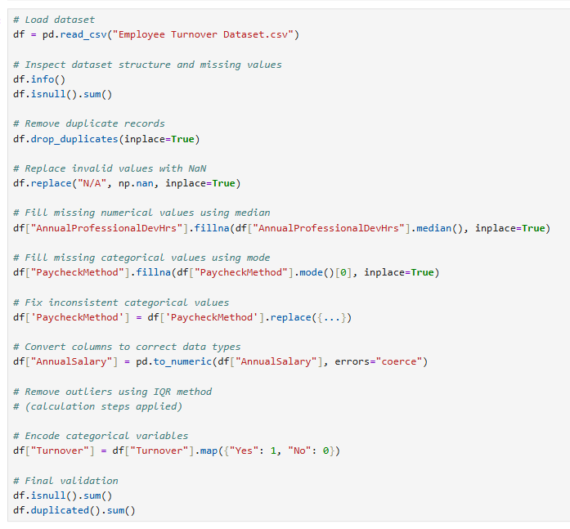
Explanation:
The code is fully annotated to clearly describe each data cleaning step, ensuring readability and reproducibility.

Project Deliverables

df.to_csv("employee_turnover_cleaned.csv", index=False)
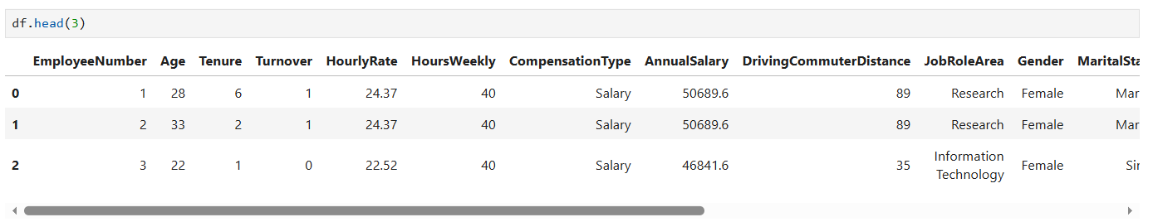
Explanation:
The cleaned dataset was exported as a CSV file for further analysis and model development.

Execution Results & Validation
Screenshots from the Python execution environment demonstrate successful completion of data quality validation, missing value treatment, duplicate removal, categorical standardization, outlier filtering, and final dataset verification.
The validation process confirmed that all identified data quality issues were successfully addressed and that the resulting dataset is suitable for workforce analytics, reporting, and predictive modeling initiatives.

Business Impact
The data preparation pipeline significantly improved the quality, consistency, and reliability of employee workforce records.
The cleaned dataset enables HR leaders and business stakeholders to:
• Analyze employee turnover trends more accurately
• Support workforce retention initiatives
• Build HR dashboards and KPI reporting systems
• Develop employee attrition prediction models
• Improve workforce planning and decision-making

Workforce Insights & Analytics Readiness
The completed data quality pipeline established a reliable analytical foundation for future workforce intelligence initiatives.
Key outcomes include:
• Standardized employee records across all workforce dimensions
• Elimination of duplicate observations
• Resolution of missing and inconsistent values
• Improved statistical reliability of salary and employee metrics
• Enhanced readiness for machine learning and predictive analytics projects

Technical References

• Pandas Documentation
• NumPy Documentation

Project Summary
This project successfully transformed raw employee workforce records into a clean, standardized, and analysis-ready dataset.
Through structured data quality assessment, missing value treatment, duplicate resolution, categorical standardization, outlier handling, and data type correction, the dataset was prepared for workforce analytics, HR reporting, and predictive attrition modeling.
The resulting dataset provides a reliable foundation for data-driven workforce planning, employee retention analysis, and future HR intelligence initiatives.

